DAD 220 Module Five Activity

Complete these steps as you work through the directions for this activity. Refer to the guidelines and rubric for help with how to complete these steps. Rename this template by adding your last name to the file name. Replace the bracketed text in the template with your responses and supporting screenshots as you complete the activity. Size each screenshot and its explanation to fit approximately one-quarter of the page. Review the Template Screenshot Example linked in the guidelines and rubric for this assignment to see how screenshots for your assignment should look. Submit the completed template for grading and feedback.

- Analyze the data provided in FleetMaintenanceRecords to identify themes.
  - Review part-replacement frequencies and types. Then create a hypothesis that the fleet management team can use to better handle maintenance.
    - Create a table called Parts Maintenance. Put this table in the database named after yourself.
    - Load the data set from the ‘/home/codio/workspace’ path and run queries to find the results. You should use the following line terminators when importing: \n.
    - Answer the following questions and provide supporting screenshots.
      - Which parts are being replaced most often?

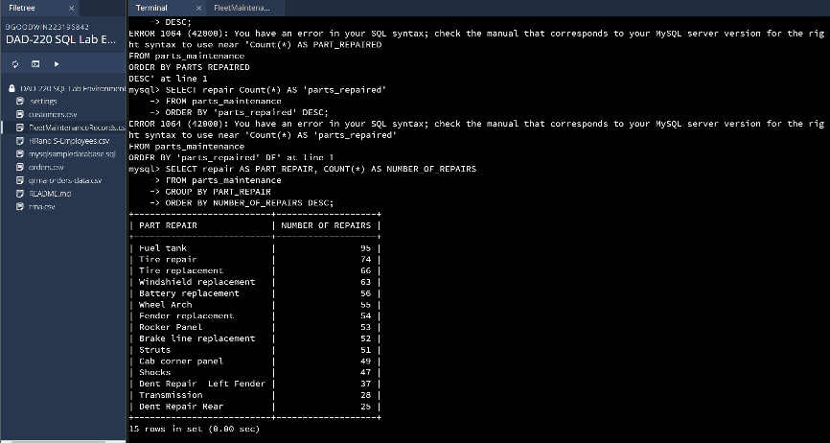
I selected the repair column as part repaired and used the count feature to represent of much of each part gets replaced, I then grouped the parts and ordered the number of times each one was repaired. Fuel tanks are the things that need the most replacing.
      - Which region or regions of the country experience more part failures and replacements than others?
      - Identify the region or regions with more reasons for the replacement of parts.
      - Use the Region Definitions sheet to identify states in each region.

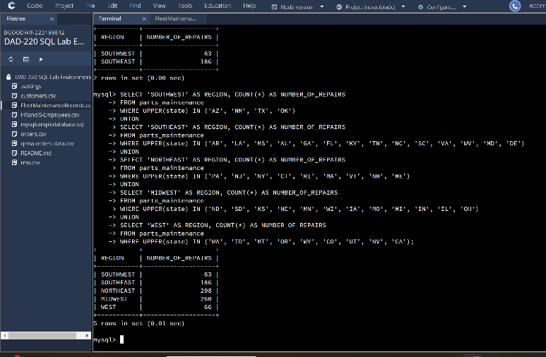
I selected a name as the region and to count the number of parts repaired by that region, I took the information from from parts_maintenance table and defined what states were in each region. This shows what repairs were needed in each region and that the northeast and the Midwest regions need the most repairs.

      - How might the fleet maintenance team use the information to update its maintenance schedule?

The fleet maintenance team can use this to predict which regions may need more repairs than others and order parts accordingly. They can also use this to show how many employees or deliveries need to be made around each region and hire accordingly.

      - Which parts are being replaced most often due to corrosion or rust?

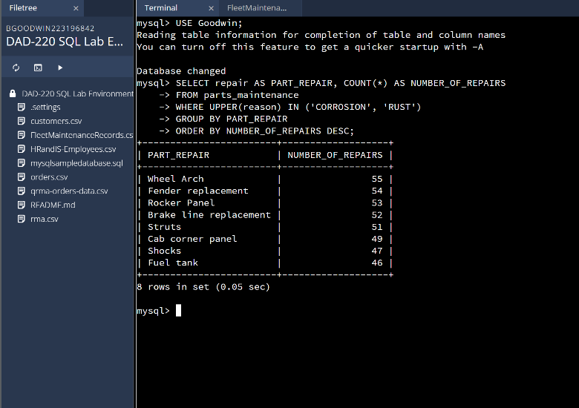
Wheel arch.
      - Which parts are being replaced most often because of mechanical failure or an accident like a flat tire or rock through the windshield?

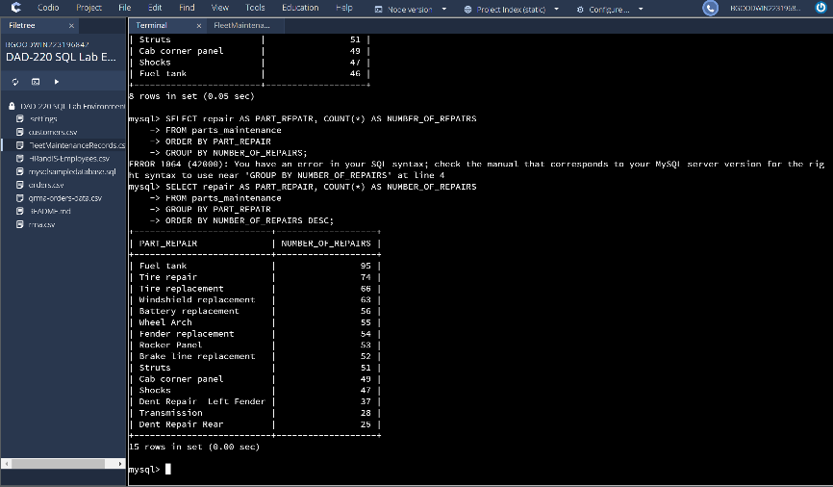
Tires
- Write a brief summary of your analysis that takes the information from step one and presents it in a way that nontechnical stakeholders can understand. Write your response in paragraph form.

The first thing that we looked at was all the parts that need to be replaced on vehicles along with how often those parts need to be replaced. Next, we split the states into the regions of Southwest, southeast, west, northeast and midwest; we created a table that shows the number of repairs that happen in each region and found the. We then created a table that shows how many of those replacements are due to rust or collision with another person. Lastly, we created a table that shows data of accidents due to mechanical failure or an accident.

- Outline the approach that you took to conduct the analysis.
  - What queries did you use to identify trends or themes in the data?

I used the group by and order by commands to make new tables out of existing information in the table repairs_maintenace. The queries returned information on types of repairs, the number of repairs needed in a region and the number of different types of repairs given circumstances which all returned different sections of information.

  - What are the benefits of using these queries to retrieve the information in a way that allows you to provide valuable information to your stakeholders?

These queries allow us to find valuable information very quickly and allow us to compare or sift through it in efficient ways. With this information we can determine what repairs need to be made, how often they need to be made, where they are being made and so much more easily. We can use this information to improve our vehicles or send appropriate replacements to where they may need to go, we can also investigate why certain areas need more repairs and trouble shoot solutions. We can make predictions on this data by using and organizing the information that we have.

- Explain how the functions in the analysis tool (MySQL) allowed you to organize the data and retrieve records quickly.
These functions allowed me to group the data together, order it, select it and return it as redefined information in a fat and productive way using the parameter given by SQL.

